Thank you for signing up to volunteer with FareShare and being part of the UK’s largest food collection. You are now part of a fantastic team of volunteers who make a big difference to the 8.4 million people currently living in food poverty in the UK.
This brief will tell you everything you need to know about being a #foodhero this Christmas at our 11th Tesco Food Collection.

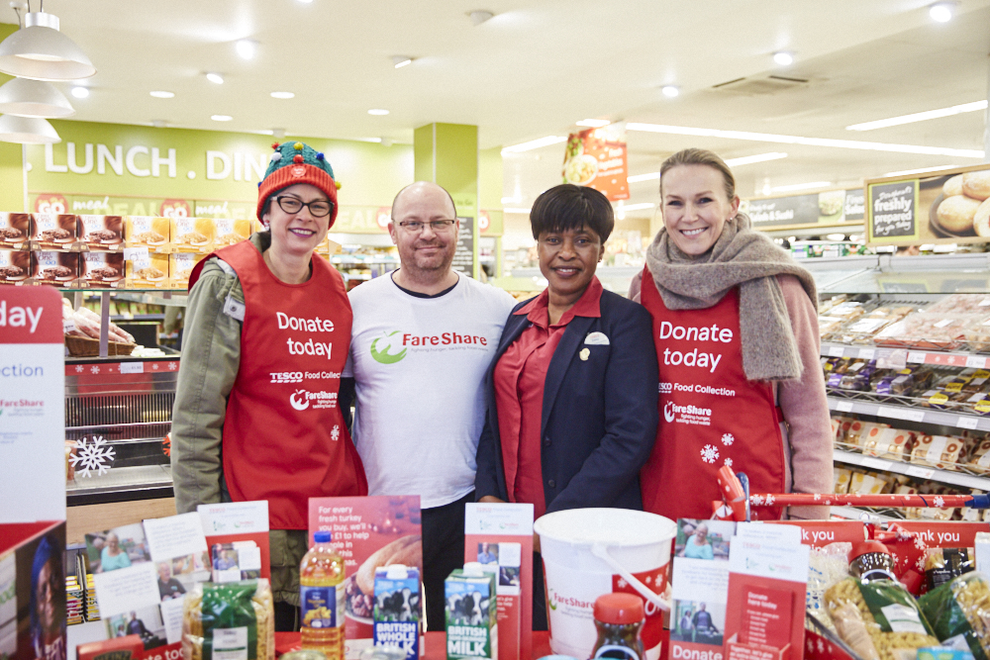
Contents
- About FareShare
- How the Tesco Food Collection works
- Where the food is going
- How to be a #foodhero
- #foodhero checklist
- Extra ideas
- Spreading the word
- FAQs
- Tesco Food Collection volunteer recruitment poster
- About FareShare
FareShare is the UK’s largest food redistribution charity, helping to support organisations such as kid’s breakfast clubs, community centres, homeless hostels and refuges. At FareShare we help over 9,653 charities make delicious and nutritious meals by saving food from going to waste. Whilst we receive a steady supply of fresh food from the food industry, we still need longer-life items such as rice, tea and tinned goods.

“Food has been a real catalyst for change among the community here this summer – not just providing new food experiences for many kids, but also connecting and engaging children and families.”
Katie Hanchard-Goodwin, Manager of Bristol Playbus

How the Tesco Food Collection works

You will be handing out the FareShare shopping list to customers as they enter the shop. The shopping list helps customers know what types of food to buy and donate to FareShare. It’s based on what our network of charities has asked for. This year the shopping list will be in priority order of the food our network requires most.

Shopping list

- Tinned meat
- Tinned soup
- Tinned baked beans
- Tinned fish
- Rice
- Pasta
- Tinned veg
- Tea
- Coffee
- UHT milk
- Healthy snacks

Customers will then be able to add an item or two to their usual shop and after they have paid, they will need to bring the donation to the collection point. This is usually a special trolley near the store exit.
As the collection point fills up with wonderful donations, Tesco colleagues will store the food for collection in the back of the shop. Please make sure that all donations are stored in citrus or banana boxes and not in the green trays.
Tesco will ensure that after the 3-day food drive, the food is delivered to the nearest FareShare Regional Centre. Tesco will also provide a 20% financial top-up to customers’ donations to provide further support to FareShare.
From the FareShare Regional Centre, the food will then be distributed throughout the year alongside fresh food, to many charities, breakfast clubs and community groups who help to provide meals for vulnerable people.

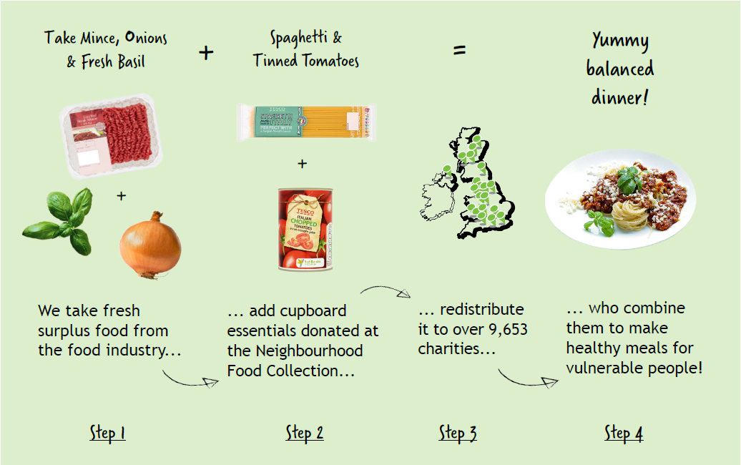

In an average 3-hour volunteer shift, you could collect enough food for
600 meals!

Where is the food going?
The food you collect will be transported to FareShare Regional Centres. From there FareShare provides the food to frontline charities and community groups that support vulnerable people – including homeless shelters, children’s breakfast clubs, older people's lunch clubs and domestic violence refuges. These organisations transform this food into nutritious meals, which they provide alongside life-changing support.

Last year, FareShare UK redistributed more than 16,992 tonnes of food to over 9,653 charities and community groups, enough to provide 36.7 million meals for people in need.

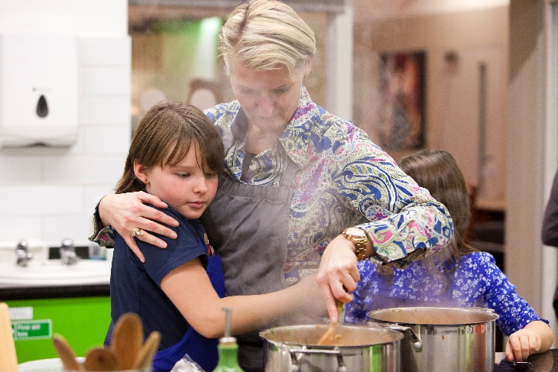
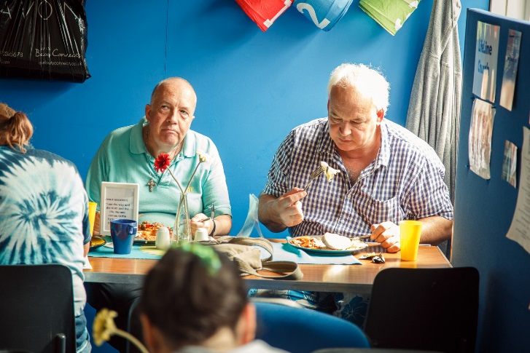

Julie Vincent, Parent Support Advisor at Millpond Primary School in Bristol tells us why receiving a regular supply of food from FareShare is so important for their school breakfast club.
Why did you decide to set up a breakfast club in your school?
“We wanted to provide opportunities for our families, children and parents to eat breakfast in a safe, secure, stimulating environment, to engage them in making healthier food choices, improve children’s attendance, punctuality, motivation and self-confidence.”

“By setting up this club, we could benefit our low-income families by providing a no-cost breakfast each weekday. Our club continues to flourish, has doubled in size since its commencement and is successful in enabling children to arrive early for school each weekday, meet with friends, take part in fun activities and, more importantly, be ready for learning at the start of the school day with the right mind-set.”
Julie Vincent, Parent Support Advisor

For more information and to read about the lives you are changing please visit: www.fareshare.org.uk/stories-behind-meals

How to be a #foodhero

On the day
Arrive fifteen minutes before your shift starts and introduce yourself at the Customer Service Desk. If you can’t find the Customer Service Desk or your store doesn’t have one, just ask a Tesco colleague for the Duty Manager. You may be asked to sign into the visitor’s book.
On arrival ask about:
- The location of the toilet facilities
- Where you can store your personal belongings.
NB: There may not be safe storage facilities, so only bring essential items with you. It is advisable that you wear your handbag or only bring items you can keep in your pockets. Tesco & FareShare can’t accept responsibility for lost items.
- Let the store know if you will require a chair or have any specific requirements whilst volunteering.
- A red tabard – like an apron – to wear over your clothes. Please leave your tabard for the next volunteers at the end of your shift. Please make sure that no other colour tabards are worn for the collection.
- Please ask where you can get copies of the FareShare shopping list, for you to hand out to customers.
- If you spot the collection point getting quite full – well done you! Let a Tesco colleague know and they should take the stock to the back area so there is room for more donations. There should be trolleys or cages with ‘Food Collection’ branding in the stock room area. Please do not attempt to lift any boxes that look too heavy and please don’t push any of the stock cages. Always ask a Tesco colleague to help.

Don’t worry if you are running late, want to take a break or need to leave a little early. Any time you can give is hugely appreciated!

Top tips
- As customers enter the shop, welcome them with a smile and offer them a FareShare shopping list. Explain how they can donate an item and where to drop it off after paying.
- Some customers may be busy or less interested in donating. This is completely fine and perfectly normal. Focus on the next customer.
- If a customer is interested in finding out more about FareShare, show them our contact details and website which can be found on the back of the shopping list.
- Here’s some suggested conversation starters for you:

“We’re collecting food for people in need, could you donate an item?”
“Help to feed someone in need by donating an item in-store today.”
“Would you be able to buy an extra item of food and donate it to charity?”

Make the most of your shift by having fun!
Most importantly we want you to have fun while volunteering. It’s Christmas so why not don a pair of antlers or a santa hat or dress up in your favourite Christmas outfit.
Make sure you snap a picture and send it to FareShare (tescofoodcollection@fareshare.org.uk). You can share your pics on social media using the hashtag #everycanhelps

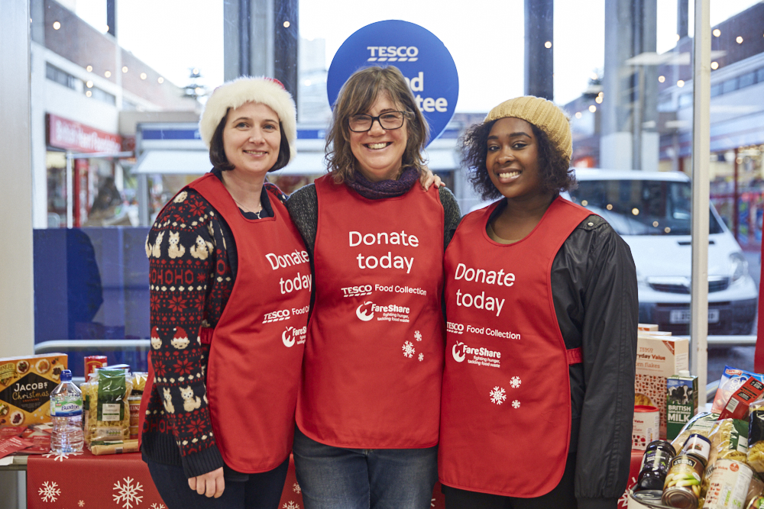

“Some Tesco customers thanked me as they left the store in such a kind, open way telling me how important my volunteering was that it warmed the cockles of my heart.”

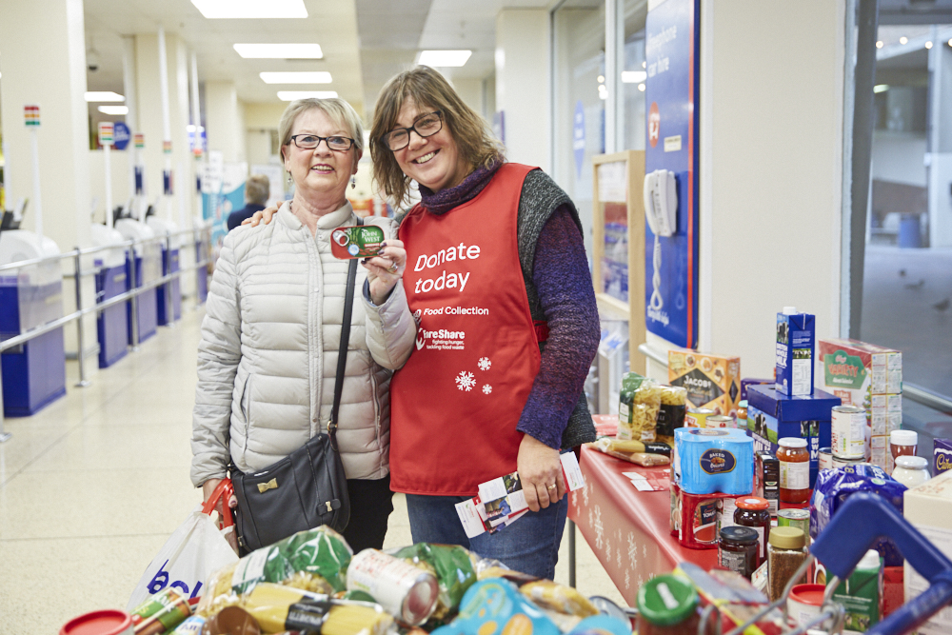

“It was rewarding to collect so much food in the 3 hours I was there and the time flew by”

#foodhero checklist
- I’ve saved my shift time, date and store address in my diary
- I’ve read my Tesco Food Collection brief (this document) cover to cover
- I know who FareShare is, why the Tesco Food Collection is important and where the food is going.
- I’ve got my coat and my comfy shoes ready for my shift.
- I’ve taken note of the contact details below – just in case!

Contact details:
tescofoodcollection@fareshare.org.uk | 0800-711-7073
If anything happens during the collection you can get hold of a member of the FareShare team on the details above.

Extra Ideas
If you want to maximise the food collection before you even begin your shift, why not get the support of friends, family and colleagues by:
- Arranging your own ‘Great Bake Off’ sale at your place of work
- Organising a swear box as a sponsored silence
- Planning your own ‘come dine with me’ experience
- Holding a bring a dish party
- Beating the winter blue smoothie party
You can use any money collected/donated to purchase extra food in store before your shift begins. It’s a great way to create an eye-catching display and will certainly add to the overall food collection.

Spreading the word
You can help us to recruit more #food heroes by sharing your poster. Here are some ideas for sharing your Tesco Food Collection Poster:
- Put the enclosed poster in your reception, staff canteen, staff intranet or newsletter
- Put in your local library, community centre, community group or a supportive organisation
- Share with friends and family

Frequently Asked Questions
Although this will be the 11th Food Collection and we aim to be as prepared as possible, sometimes things don’t always go to plan. If anything does go awry, it’s important to try not to let it dampen your enthusiasm. Here’s a few ‘what if’ scenarios:

What if…
… my store doesn’t have tabards or shopping lists?
These items should have been delivered into store on the Thursday before the collection. Ask the Tesco Duty Manager to check and if there’s still no sign of them, please get in touch with the FareShare helpline on 0800-711-7073.

… my store wasn’t expecting me?
Each store should have been told when to excpect volunteers, but don’t worry if the store colleagues weren’t expecting you. Just explain that you are there as a FareShare volunteer for the Food Collection. If you need to, ring the FareShare helpine on 0800-711-7073.

… there aren’t any other volunteers?
Due to the scale of the Tesco Food Collection, it is not always possible to recruit volunteers for each shift in every store, which is why you mean so much to us! If you really do not fancy volunteering by yourself, you can always recruit a friend and sign them up with you – the more the merrier.

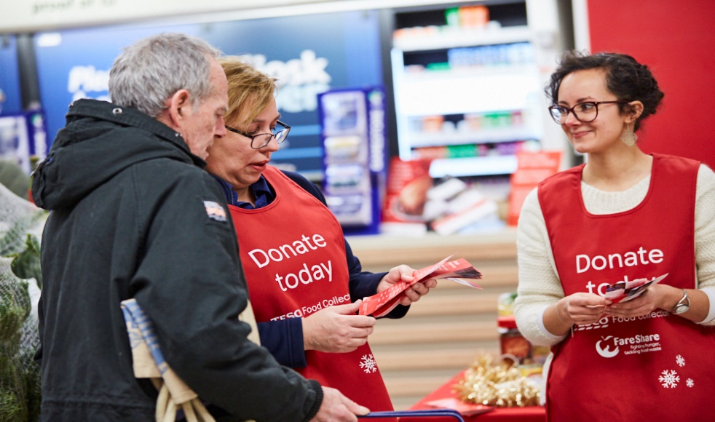
… customers ask me a question I can’t answer?
If you don’t know the answer to a customer’s question or you don’t feel entirely confident answering, you can always direct the customer to our website : www.fareshare.org.uk where there is plenty of information. They can also e-mail: tescofoodcollection@fareshare.org.uk These details will all be printed on the back of the shopping list.

… an accident happens?
If any accident or emergency happens, please inform the Tesco Duty Manager. This includes if any customers are being difficult with you. Please also let us know if anything like this happens by e-mailing us on tescofoodcollection@fareshare.org.uk or calling us on the helpline number: 0800-711-7073. This activity has been risk-assessed for volunteers.

… someone gives me food which is not on the list?
Some customers will want to donate mince pies or other chrsitmas treats. Kindly explain to the customer that these items are likely to be damaged, however it would be greatly appreciated if they would swap them for an item in a tin or packet. You can if you prefer, address this with a member of colleagues at the end of your shift, they will support you to switch non-shopping list items for the same value of food stuff we require.

Some wider information about FareShare
How can a charity or an individual access the food that is donated to FareShare?
Charities or community groups can find out more about how to access both long-life and fresh food from FareShare by visiting this page on our website: www.fareshare.org.uk/getting-food. Groups can save an average of £7,900 off their food bill per year by signing up to FareShare.
At FareShare, we work with charities and community groups rather than providing food for individuals. If someone asks about how individuals can access food, we recommend our partners at the Trussell Trust who run a national network of foodbanks: www.trusselltrust.org/get-help/.

Does Tesco give fresh food to FareShare? What about food waste?
Tesco currently donates surplus food (that’s anything which might be wasted rather than sold) from it’s distribution centres to FareShare. At store-level, Tesco runs the Community Food Connection programme in partnership with FareShare, which allows unsold food to be offered to local charities and community groups..

More ways to get involved with FareShare?
There are many more ways to help fight hunger and tackle food waste. We’re always looking for volunteers at our Regional Centres or if you want to fundraise, for every £1 we can provide food for 4 meals! Find out more by visiting our website or by following us on social media.

Website: www.fareshare.org.uk | Twitter: @FareShareUK | Facebook: UK FareShare

Thank you and we hope you enjoy being a #foodhero at the UK’s largest food collection! From all of us at FareShare.

