ID | Picture | Description | Fabric | Link | No | Cost
 | 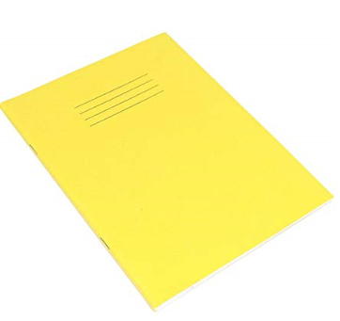 | Exercise Book (for recording sessions) |  | https://www.amazon.co.uk/RHINO-VEX342-504-8-200x165-Page-Exercise/dp/B00JHDP9MK/ref=sr_1_10?ie=UTF8&qid=1534251286&sr=8-10&keywords=exercise+books | 5 | £4.33 (+ postage)
 | 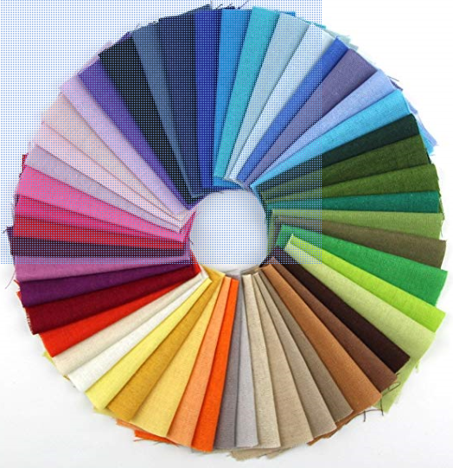 | Fabric Solid Color Bundle |  | https://www.amazon.co.uk/RayLineDo-Different-Pieces-Patchwork-Squares/dp/B014T474BU/ref=sr_1_2?ie=UTF8&qid=1534250970&sr=8-2&keywords=fabric+samples | 1 | £5.19
 |  | Memorabilia Gift Packs |  | https://www.amazon.co.uk/Childhood-Memorabilia-pieces-Replica-Artwork/dp/B01B7TJGPC/ref=sr_1_11?s=kids&ie=UTF8&qid=1533210358&sr=1-11&keywords=Memorabilia+Gift+Packs | 10 | £6.50
 | 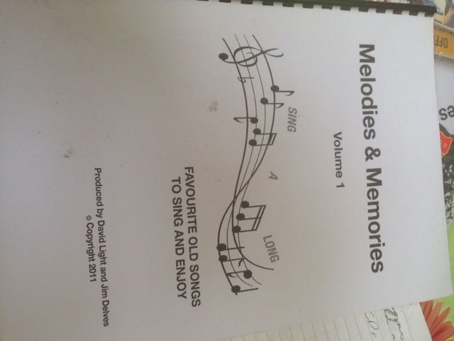 | Melodies & Memories CD and 'Sing-a-long' Book |  | http://www.carerspathways.org.uk/Melodies_Memories/MandM%20Shop/mandm_shop.html | 2 CDs and 10 books for each CD | CDs £6.50 Each + P&P  Songbooks £1.50 each
 | 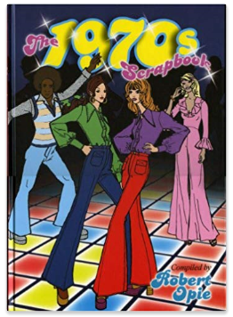 | Reminiscence books |  | https://www.amazon.co.uk/1970s-Scrapbook-Robert-Opie/dp/0954795407/ref=pd_sim_14_4?_encoding=UTF8&pd_rd_i=0954795407&pd_rd_r=e28e68cd-964a-11e8-8574-71caab6fdff9&pd_rd_w=I4z7q&pd_rd_wg=LRrCl&pf_rd_i=desktop-dp-sims&pf_rd_m=A3P5ROKL5A1OLE&pf_rd_p=3274180622111699416&pf_rd_r=W0YY7513NHC9RWZS7JD1&pf_rd_s=desktop-dp-sims&pf_rd_t=40701&psc=1&refRID=W0YY7513NHC9RWZS7JD1 | 8 | £11.50
 | 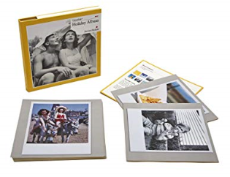 | Reminiscence Cards |  | https://www.amazon.co.uk/Active-Minds-Holiday-Reminiscence-Cards/dp/B01MSBHWU9/ref=sr_1_26_sspa?s=kids&ie=UTF8&qid=1533210746&sr=1-26-spons&keywords=dementia&psc=1 | 8 | £11.99
 |  | Memorabilia jigsaws |  | https://www.amazon.co.uk/Gibsons-Spirit-Jigsaw-Puzzle-piece/dp/B01MTLDVN2/ref=sr_1_2?ie=UTF8&qid=1533210265&sr=8-2&keywords=70s+jigsaw  and  https://www.amazon.co.uk/Active-Minds-Orient-Express-Jigsaw/dp/B017XV9FL8/ref=sr_1_34?s=kids&ie=UTF8&qid=1533210653&sr=1-34&keywords=dementia | 6 | £11.85 - £14.99
 | 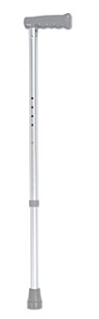 | Walking sticks |  | https://www.amazon.co.uk/NRS-Healthcare-Walking-Adjustable-Height/dp/B00667BEK6/ref=sr_1_8_a_it?ie=UTF8&qid=1534248710&sr=8-8&keywords=walking+sticks | 10 | £11.03
 | 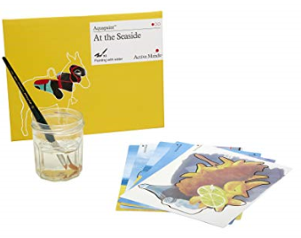 | Aquapaint (Reusable Water Painting) |  | https://www.amazon.co.uk/Active-Minds-Aquapaint-Reusable-Painting/dp/B01LQMNSKO/ref=sr_1_1?s=kids&ie=UTF8&qid=1533210480&sr=1-1&keywords=aquapaint | 10 | £17.50
 |  | Gardenesque Feather Planter, Blue |  | https://www.amazon.co.uk/Gardenesque-FDRGLBL-Feather-Planter-Blue/dp/B07D3D597D/ref=sr_1_49_sspa?s=outdoors&ie=UTF8&qid=1533215933&sr=1-49-spons&keywords=plant+pot&psc=1 | 8 | £19.99
 | 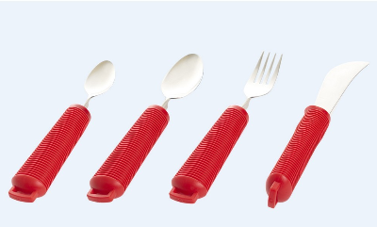 | Bendable Cutlery |  | https://www.unforgettable.org/bendable-utensils-4-piece-kit | 10 | £19.99
 | 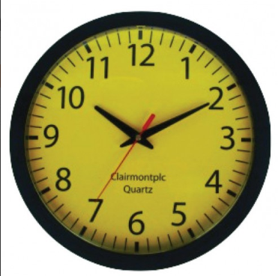 | Low vision yellow clock |  | https://clairmontplc.com/index.php?route=product/product&path=61&product_id=56 | 4 | £24.00
 | 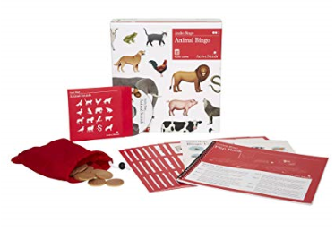 | Audio Bingo |  | https://www.amazon.co.uk/Animal-Audio-Bingo-Specialist-Alzheimers/dp/B0742HPQB4/ref=sr_1_39?s=kids&ie=UTF8&qid=1533210746&sr=1-39&keywords=dementia | 1 | £24.99
 | 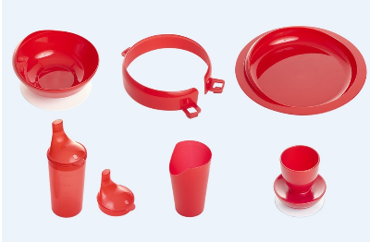 | Standard Tableware Set |  | https://www.unforgettable.org/standard-tableware-set | 10 | £27.90
 | 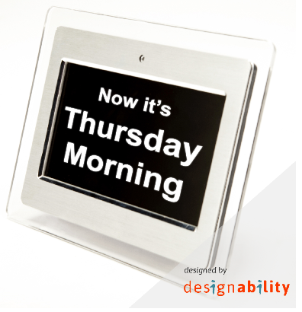 | Day Clock |  | https://www.unforgettable.org/the-day-clock?source_ref=day_clock_buying_guide | 5 | £53.90
 | 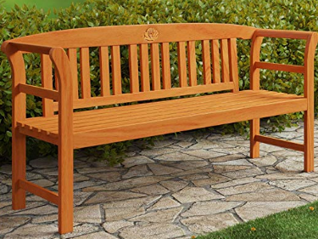 | Deuba Garden Bench Rose 2-Seater Wooden Garden Furniture Hardwood Patio Seating Large with Armrests |  | https://www.amazon.co.uk/2-Seater-Furniture-Hardwood-Seating-Armrests/dp/B00YN2O0VQ/ref=sr_1_2_sspa?ie=UTF8&qid=1533215422&sr=8-2-spons&keywords=garden+bench&psc=1 | 2 | £62.95
 |  | Reminiscence Prints |  | N/A – 10 pictures have been sourced from community archive. They would be printed at CDS Print and Creative (£0.12 each) and mounted in frames from Ikea (£7.00 each) | 10 | £71.20 for all 10
 | 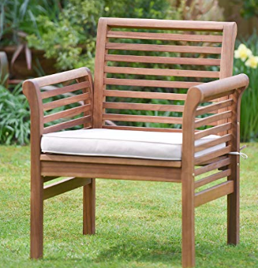 | Plant Theatre Hardwood Garden Sofa Armchair with Cushion |  | https://www.amazon.co.uk/Plant-Theatre-Hardwood-Armchair-included/dp/B07BY9PTS6/ref=sr_1_5?s=outdoors&ie=UTF8&qid=1533215797&sr=1-5&keywords=wooden+garden+chair | 4 | £79.99
 | 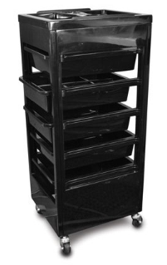 | Esthetix salon trolley, black |  | https://www.ellisons.co.uk/furniture/esthetix-trolley-black.html | 1 | £84.95
 |  | 8” Tablet – Canary Yello |  | https://www.amazon.co.uk/gp/product/B01J94T8M8/ref=fs_dou?th=1 | 8 | £84.99
 | 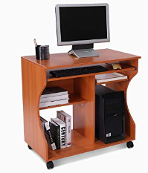 | Wheeled Computer Cart - Cherry Wood |  | https://www.amazon.co.uk/HomCom-Wheeled-Computer-Cart-Cherry/dp/B01AO1HLL0/ref=sr_1_4?ie=UTF8&qid=1533206913&sr=8-4&keywords=wheeled+computer+desk | 11 | £39.99
 | 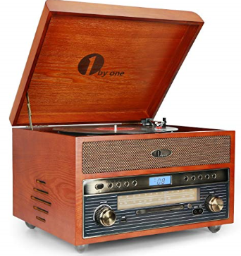 | 1byone Nostalgic Wooden Turntable Vinyl Record Player with AM/FM, CD,USB for MP3,Vinyl-to-MP3 Recording,AUX Input for Smartphones and Tablets and RCA Output |  | https://www.amazon.co.uk/1byone-Nostalgic-Turntable-Recording-Smartphones/dp/B075N7ZHXT/ref=sr_1_24?ie=UTF8&qid=1533205925&sr=8-24&keywords=old+fashioned+stereo | 1 | £140.00
 | N/A | Petroc Beauty Kit 18: basic set-up salon consumables. |  | Order through Adult Learning Service | 1 | £197.60
 | 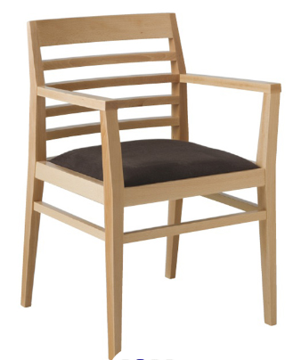 | Hadley dining arm chair |  | https://uk.pineapplecontracts.com/product/hadley-chair/ | 12 | £200.80 + VAT
 | 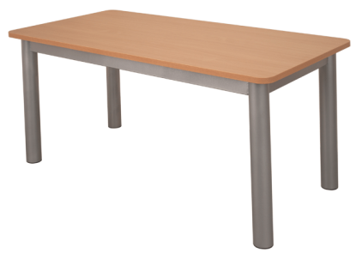 | Heavy Duty Rectangular School Table |  | http://www.toughfurniture.com/product/heavy-duty-rectangular-school-table/ | 4 | £381.00 + VAT
 | 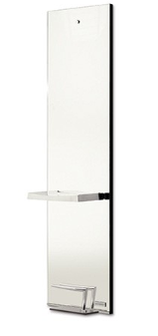 | Salon Ambience titanium salon mirror unit |  | https://www.ellisons.co.uk/salon-ambience-titanium-mirror.html?___store=default&nosto=nosto-page-product1 | 4 | £439.00
 | 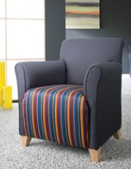 | Eclipse low back chair |   Teal 151 | https://uk.pineapplecontracts.com/product/eclipse/?ajax | 16 | £483.00+ VAT
 | 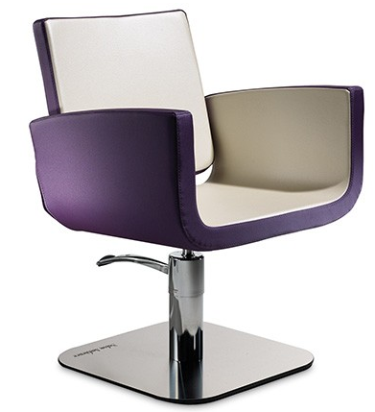 | Salon Ambience you salon chair |  | https://www.ellisons.co.uk/furniture/hair-salon/chairs/salon-ambience-you-chair.html | 4 | £498.00
 | 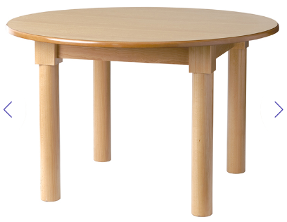 | Canterbury Plus dining tables |  | https://uk.pineapplecontracts.com/product/canterbury-plus/?filters%5B0%5D=998&all=1 | 3 | £1,378.00+VAT

End

